Student’s name | …………………………………………………….…… | Grade | 5
Subject | Computer | Week No. | 4
Lesson Title | Paper Plane | Unit
Worksheet No. ( 4 ) (Answer)
Question A: Write the correct name of each part.

Paper planes (P69)
LIFT | DRAG | THRUST | GRAVITY
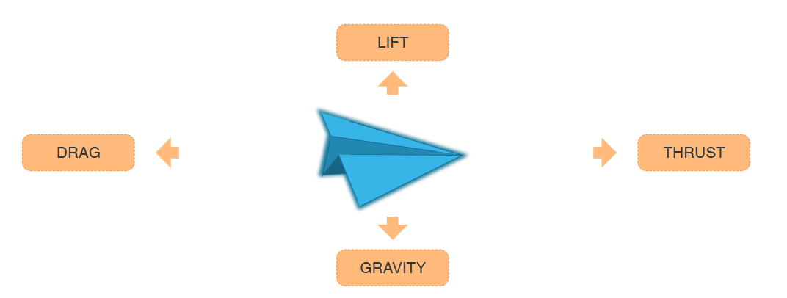
DRAG
THRUST
LIFT
GRAVITY
Good Luck

